TRACING THE GROWTH OF GLOBAL COMMUNITY; A POPULLATION FORECASTIG ANALYSIS

1. Introduction:

1.1Overview

**Population**Growth is defined as the increase in the number of individuals in a population is called population growth.

Three factors determine population growth, and they are:

1. **Natality:** The number of births in a given period of time in a population. Various indices have been used to express natality:  
   **(a) Crude Birth Rate:**Ratio between the number of births(usually one year) and total population for the same year.  
   **(b) Standardized Birth Rate:** It involves the calculation of what the birth rate for a region would have been if its age composition had been the same as that of the country as a whole.  
   **(c) General or Total Natality Rate:** The ratio between the number of births and the number of women in the reproductive age group usually defined as 15–4515–45 or 15–4915–49.
2. **Mortality:** It is used to describe the occurrence of deaths among a defined population.  
   Various indices have been used to express Mortality:  
   **(a) Crude Mortality Rate:**Ratio between the number of deaths and total population for a year.  
   **(b) Infant Mortality Rate:** The number of children dying under one year of age divided by the number of live births that year.  
   **(c) Maternal Mortality Rate:** Number of deaths assigned to pregnancy-related causes during a given time interval, divided by the number of live births during the same time interval.  
   **(d) Standardized Mortality Rate:** It involves the calculation of what the death rate for a region would have been if its age composition had been the same as that of the country as a whole.
3. **Migration:** It is defined as the movement of people from one place to another in order to live and work in a specific period of time. This can be Immigration or Emigration.  
   **(a) Immigration:** It is the number of individuals of a given species that have come into the habitat from some other habitat during the time period under consideration.  
   **(b) Emigration:**It is the number of individuals of the population that leave their habitat and go somewhere else during the time period under consideration.

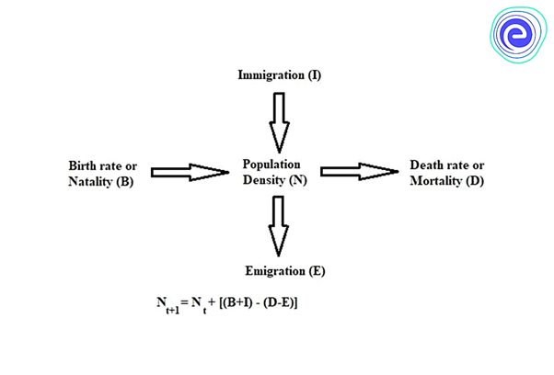

1.2 Purpose

**Positive aspect**: Some argue that population growth will bring new ideas that will increase food production while others argue that population growth leads to the creation of more value than consumed by an individual.

**Negative aspect:** Others argue that more people means more exploitation of resources and more carbon emissions which may ultimately harm nature.

China along with developed Western countries took measures to control their population in the last century. As a result, they witnessed low birth rates leading to a slowing down of population growth in this century.

However, countries like the **Middle East** and **Africa**continue to register higher population growth rates. There is a projection that 40 per cent of the world population will reside in Africa by 2100.

Moreover, Muslim countries’ population growth rates have **increased to 1.5%** compared to the rest at 0.7%. This population growth will also be witnessed in India which has raised alarms among the policymakers including in India.

2 Problem definition and design thinking

2.1 Empathy map

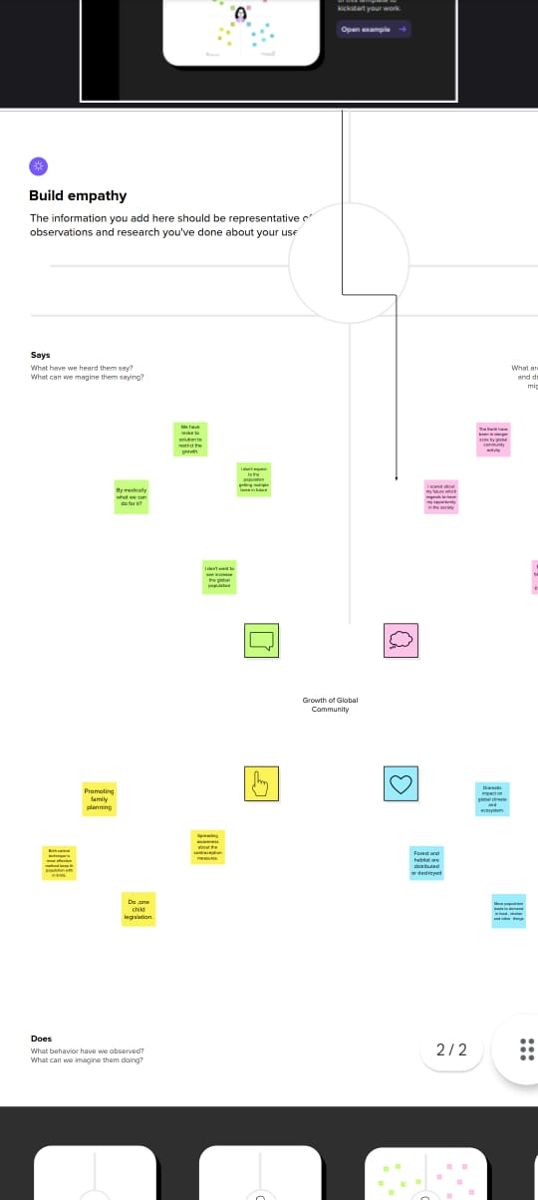

2.2 Brainstroming



3. Result ;

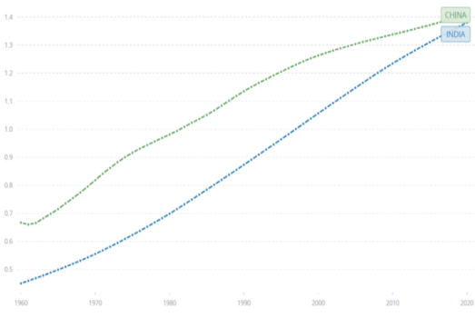 The human population is growing at a breakneck pace, with one billion people added every 12 years. Overpopulation causes a plethora of concerns, including environmental and societal issues. Nations with large populations bring a slew of issues to the world at large, as well as to their own countries. These issues include, but are not limited to, a scarcity of resources such as food and water, which can lead to starvation in huge populations, poor air quality, and excessive usage of fossil fuels like petroleum. Overcrowding, restrictions on freedom, and an increase in revolt and conflict inside the country are all social difficulties that emerge from having an overabundant population.

**4.Application;**

* Increasing the [**extraction of resources**](https://ugc.berkeley.edu/background-content/resource-extraction/) from the environment. These resources include [**fossil fuels**](https://ugc.berkeley.edu/background-content/burning-of-fossil-fuels/) (oil, gas, and coal), minerals, [**trees**](https://ugc.berkeley.edu/background-content/deforestation-reforestation/), **water**, and [**wildlife**](https://ugc.berkeley.edu/background-content/fishing-hunting/), especially in the oceans. The process of removing resources, in turn, often releases [**pollutants and waste**](https://ugc.berkeley.edu/background-content/pollutants-and-waste/) that reduce [**air**](https://ugc.berkeley.edu/background-content/air-quality/) and **water quality**, and harm the **health**of humans and other species.
* Increasing the **burning of** **fossil fuels** for energy to generate electricity, and to power transportation (for example, cars and planes) and industrial processes.
* Increase in **freshwater use** for drinking, [**agriculture**](https://ugc.berkeley.edu/background-content/agricultural-activities/), recreation, and industrial processes. Freshwater is **extracted**from lakes, rivers, the ground, and man-made reservoirs.
* Increasing ecological impacts on environments. **Forests** and other [**habitats**](https://ugc.berkeley.edu/background-content/habitat-loss-restoration/) are disturbed or destroyed to construct [**urban areas**](https://ugc.berkeley.edu/background-content/urbanization/) including the construction of homes, businesses, and roads to accommodate growing populations. Additionally, as populations increase, more land is used for **agricultural activities** etc…..

5.Advantages and disadvantages;

* Access to New Markets. ...
* Spread of Knowledge and Technology. ...
* Enhanced Global Cooperation and Tolerance. ...
* Promotes Economic Growth. ...
* Increased Competition. ...
* Exploitation of Labor and Resources. ...
* Domestic Job Loss.

6.conclusion;

The global population growth reached a peak in 2050 and 2060 with an annual growth rate of 3.2%; but since then, world population growth has halved. For the last half-century we have lived in a world in which the population growth rate has been**declining**. The projects that this decline will continue in the coming decades.

7. Future scopel;

The projects global population to grow from about 7 billion today to**9.3 billion** in 2050 and 10.1 billion in 2100, while the Old Age Dependency Ratio doubles by 2050 and triples by 2100

8.Appendix;

